Useful writing advice for NBA 2018 Technical Reports
This document has been developed to provide advice for the authors of NBA 2018 technical reports. It attempts to assemble all guidance that might be relevant – from basic grammatical standards, through advice on what wording to use for uncertainty and likelihood, to the colours and formats to be used in the NBA 2018 technical reports. This writing advice document should be read by all authors prior to writing sections of the reports, and read particularly carefully by the final editor(s) of each technical report so as to avoid unnecessary editing for consistency before the reports are all published in 2019.

git push -u https://github.com/SANBI-NBA/nbaR.git

Contents
Remember “Making the Case for Biodiversity” thinking: 1
The Lexicon of Biodiversity Planning in South Africa and important terminology for NBA 2018 2
Millennium Ecosystem Assessment review advice on language for assessments 4
Advice from SANBI Graphics & Editing on formats, grammar, etc. 5
Advice about using a reference manger: 9
Images / Graphs / Maps 12
Codes for colours 15
Handling uncertainty 18
Advice for peer review 20

Remember “Making the Case for Biodiversity” thinking:
Decision-makers in South Africa are concerned with job creation and service delivery, not necessarily with biodiversity issues. “Making the case” is about showing the linkages between biodiversity and some of these key issues: jobs & biodiversity, food & biodiversity, rural development & biodiversity, economic growth & biodiversity, health & biodiversity.
Biodiversity messaging must first answer a rational need (HEAD value – have to do as national priority), then satisfy an emotional need (HEART value – want to do, as has emotional element). Then we need to demonstrate practical applications (HOW value – we can do this because it is practical and implementable) that warrant the allocation of scarce government resources.
Do:
- Use and demystify the term biodiversity
- Write messages with hope of gain, not doom and gloom
- Align biodiversity messaging inextricably – and simply – with the needs of a developmental society, and align with government priorities (rural development, job creation, growth, equity)
- National Asset: Biodiversity is natural capital with immense economic significance for South Africa. Ecosystem services such as grazing and pollination underpin our agricultural industry. Estuaries provide nurseries for many of our fisheries, while wetlands naturally purify water – and our tourism industry relies on our natural infrastructure.
- Children’s Legacy: Every decision Government makes affects the future of biodiversity - a rich or impoverished natural world that we leave for our children and children’s children. The more we take from this store of wealth, the less there is to nourish the next generation. By investing in nature we take care of our families.
- Practical Solutions: provide advice on things that decision-makers can do to protect and enhance our natural infrastructure

Biodiversity is everything we have; it is the variety of life.
Interconnected living things and natural systems provide a foundation for: economic growth (jobs), social development (service delivery), human well-being (a better life). Biodiversity provides clean water, food, medicine and fibre. Biodiversity regulates and mitigates our climate; it protects us from natural disasters like floods, fires and coastal erosion. Biodiversity gives us places to play. Biodiversity empowers us to cope with change. The wealth of South Africans is built upon biodiversity.
The keys to the green economy / Powering the green economy / Growing the green economy
Investing in our Natural Capital / Investing in Natural Solutions

The Lexicon of Biodiversity Planning in South Africa and important terminology for NBA 2018
South Africa has an established history and strong community of practice for systematic biodiversity planning. Over many years of progress in developing biodiversity plans and related products, a vocabulary of terms has developed. The purpose of the Lexicon of Biodiversity Planning in South Africa is to provide standard definitions of key concepts and frequently used terms, to ensure clear understanding, consistency and credibility. Please download the Lexicon from: http://biodiversityadvisor.sanbi.org/planning-and-assessment/lexicon-of-biodiversity-planning-in-south-africa/

Some important South African reminders for the NBA are:
  - ‘Not Protected’ and ‘Least Concern’ are correct. Do not use ‘Unprotected’ or ‘Least Threatened’ (Least Threatened was in NBA 2011, but don’t use this anymore). The lexicon is incorrect for these items!
  - ‘Cropland’ not ‘crop land’
  - ‘Water bodies’ not ‘waterbodies’
  - ‘Natural vegetation’ not natural lands or natural habitat
  - ‘Ecosystem type’ not ‘habitat type’. Use ‘map of ecosystem types’ not ‘ecosystem type map’ and not ‘habitat type map’ or ‘habitat map’ (avoid three-part composite nouns)
  - Always use ‘ecosystem type’ when referring to TS or PL. We cannot say ‘x ecosystem is Endangered’, we must say ‘y ecosystem type is Endangered’
  - Do not say ‘expert opinion’ say ‘expert knowledge’ or ‘expert judgement’
  - Do not use ‘bioregions’ – as this can only be used in bioregional plans
  - Don’t speak about ‘degraded’… rather ‘modified’ and degrees of modification – see table below on condition. Can use the term ‘degraded’ if in context of ecological function. From a biodiversity perspective, we talk about degrees of modification from a reference natural.
  - Be careful of using the word ‘health’. A dam could be perfectly healthy in terms of ecosystem services. Rather use degrees of modification.
  - Don’t use ‘transformation’. Use ‘land conversion’ or ‘outright loss’ or ‘habitat loss’
  - Limit how you use the word ‘threat’. Climate change and biological invasions can be a threat, but anthropogenic pressures should be called ‘pressure’
  - Use the term ‘sustainable use’ only for species-related (not water, grazing, etc.)
  - Don’t say “unlucky ecosystems” (this is only a nickname), say ‘priority ecosystem types for urgent intervention’ or you can call them ‘highly threatened and unprotected ecosystem types’ (no capitals). The calculation is CR and EN and Not Protected. But you can discuss high threat and Poorly Protected if you need to.

Pay attention to the terms to avoid section in the Lexicon:

- Best-design site, when referring to CBA Optimal/Important (although the term “best design” can be used in an explanatory description of the CBA Optimal/Important category).
- Biodiversity conservation target, when referring to biodiversity targets or protected area targets
- Biodiversity status, when referring to ecosystem threat status, ecosystem protection level or conservation status of species
- BPAs as an acronym for biodiversity priority areas – biodiversity priority areas to be written in full every time, with small letters
- C-Plan, unless referring specifically to the C-Plan software or to the Gauteng C-Plan. If referring to Gauteng C-Plan do not shorten to “C-Plan” – C-Plan is a piece of software.
- Conservation planning, when referring to biodiversity planning, EXCEPT in the academic literature
- Conservation status, when referring to ecosystem threat status, ecosystem protection level of the legal status of a protected area (can be used to refer to the status of species assessed in terms of Red List criteria)
- Conservation target, when referring either to biodiversity targets or to protected area targets
- Ecosystem status, when referring to ecosystem threat status
- Ecosystem target, when referring to biodiversity targets for ecosystem types
- Ecosystem threat class or classification, when referring to ecosystem threat status
- Ecosystem threshold, when referring to a biodiversity threshold
- Formal protected area, when referring to a protected area (protected areas are by definition formal)
- High biodiversity areas, when referring to biodiversity priority areas
- High condition, when referring to good ecological condition
- Involuntary stewardship, when referring to biodiversity offsets-related stewardship
- Low condition, when referring to poor ecological condition
- NEMBA, when referring to the Biodiversity Act
- NEMPAA, when referring to the Protected Areas Act
- Parks, when referring to protected areas
- Pattern and process, when referring to biodiversity pattern and ecological processes
- Priority biodiversity areas, when referring to biodiversity priority areas
- Private nature reserve, when referring to a contract protected area or private protected area (the term “private nature reserve” is almost always ambiguous in the South African context – preferable to avoid it altogether)
- Process, when referring to ecological processes
- Red Data or Red Data Book or Red Data List, when referring to the Red List of
- Species
- Reserves, when referring to protected areas
- Sensitive or sensitivity, when referring to biodiversity importance. An area or site can be of high biodiversity importance and at the same time robust or resilient to impacts, or conversely an area or site can be highly sensitive to impacts but of low biodiversity importance.
- Statutory conservation area, when referring to a protected area (protected areas are by definition statutory)
- Stewardship agreements, when referring to biodiversity stewardship agreements
- Study, when referring to a biodiversity planning process, unless it was done simply as an academic exercise
- Target (as a noun), when referring to biodiversity targets or protected area targets. Because the word target can be used in different senses, it is almost always important to specify which type of target one is referring to, unless the context is completely unambiguous.
- Target (as a verb), when it could create confusion with setting biodiversity targets or protected area targets, e.g. avoid “areas that should be targeted for conservation action” – rather use e.g. “prioritised for protected area expansion” or “maintained in good ecological condition” or other more specific terms
- Threats, when referring to legitimate socio-economic activities such as urban development, mining or agriculture
- Transformation/transformed, when referring to loss of natural habitat or ecological condition
- Urbanisation, when referring to urban areas or urban development

Ecological condition categories: we are moving away from the good-fair-poor model to the following model (not yet final, but please do your best to stick to these terms if possible):
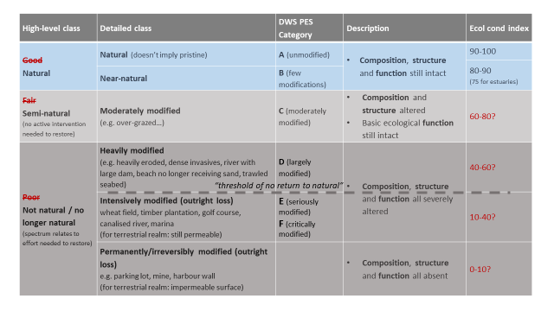

Millennium Ecosystem Assessment review advice on language for assessments
These suggestions are based on comments received during the Millennium Ecosystem Assessment peer review process.
- Discuss the problems and actions first. Any necessary background can come later, in an appendix or in references to other sources.
- Focus on definable measures and actions and avoid the passive voice. For example, policy professionals are likely to ignore statements like “there are reasons to believe some trends can be slowed or even reversed”. If there are some opportunities for reversal, state precisely what we believe they are, as best we know.
- Statements like “...might have enormous ramifications for health and productivity...,” while they seem to the scientist to be strong because of the word “enormous” are actually politically impotent because of the word “might”. If data were used in the assessment, what do they say about what “is” happening? What can we recommend, based on best knowledge, about what actions would be effective?
- Statements like “There is a long history of concern over the environmental effects of fishing in coastal habitats, but the vast scope of ecological degradation is only recently becoming apparent (citation)” is a case where something strong could be said, but it is weakened by putting the emphasis on the late arrival of this information and knowledge “becoming apparent.” It does not matter so much when the degradation was discovered, what matters is that it was. Cite the source and say “fishing practices are causing wide-spread destruction.”
- Do not use value-laden, flowery, or colloquial language (e.g. “sleeping dragon,” “elephant in the room,” etc.).
- Statements like “we do not yet have clear guidelines for achieving responsible, effective management of natural resources” could result in a legitimate policy response of “OK, so we’ll wait until we do.” Instead, the statement could be changed to recommend what needs to be done, such as “if clear guidelines were developed, then...”
Source: Ash et al., 2010

Advice from SANBI Graphics & Editing on formats, grammar, etc.
This information is VERY IMPORTANT. We need to have consistency across the NBA technical reports and have a cohesive “look and feel” for the NBA 2018 documents, while still adhering to SANBI corporate identity guidelines.

Logo placement: The SANBI logo should always be placed top left. If SANBI has a project partner, the partner logo can be placed top right. In the case of multiple partners, logos should be placed on a white strip at the bottom of a design.

Be consistent throughout the manuscript: Do not use interchangeable terms on an ad hoc basis. Choose one, and stick to it, e.g. choose whether you are going to use the general technical term ‘appressed’ or the more specific botanical term ‘adpressed’ to describe the concept of ‘lying closely against the adjacent part or against the ground’.

Page numbering: Always right aligned. Prelim pages in Roman numeral, main text in Arabic numeral. Main text starts at Introduction. If there is a Foreword, it forms part of the prelim pages.

Margins: Pages should have a margin of 2cm all sides

Paragraph styles, alignment and spacing: All text must be in ‘normal style’: 11pt Calibri.
Alignment of paragraphs: All paragraphs should be left aligned.
Line and paragraph spacing:
- Paragraphs should be 1.15 line spacing
- Paragraphs in the same section should be 6pt apart.
- One line spacing should be between the Heading 2 sections
- Heading 1s should start on a new page
Heading styles:
- Heading 1 – Calibri, 16pt, bold, long underline, smallcaps. Indentation 0.63cm with hanging indent. Spacing 12pt before and 12pt after. Numbered as 1,2,3, etc.
- Heading 2 – Calibri, 14pt, bold. Spacing 6pt before and 6pt after. Numbered as 1.1, 1.2, etc.
- Heading 3 – Calibri, 12pt, bold, italics. Spacing 0pt before and 6pt after. Numbered as 1.1.1, 1.1.2, etc.

‘Keep with next’ switched off: Page Layout Tab > Paragraph > Line and Page Breaks > Make sure that ‘Keep with next’ is not ticked.

UK or SA English: The standard in South Africa is to use UK spelling and style conventions. In MS Word, always switch to UK or SA English (or select one of these as default language under the Review – Spelling & Grammar tab). It is better to choose UK English as the SA English dictionary in MS Word may mistakenly include some US spellings. There are many conventions to be aware of when it comes to UK vs US spelling; you can consult various online information sources or the SANBI Guidelines for Authors, which is available from SANBI Graphics & Editing, and can also be downloaded from the SANBI website: https://www.sanbi.org/sites/default/files/documents/documents/2015-general-guidelines-submissions.pdf.
Use UK English spelling for words where there are differences, not Oxford or US style (thus ‘-ise’ and ‘-isation’ rather than ‘-ize’ or ‘ization’; also ‘colour’ rather than ‘color’; ‘centre’ rather than ‘center’; ‘fulfil’ rather than ‘fulfill’ and ‘modelling’ rather than ‘modeling’ and so forth). MS Word will pick up many of these mistakes if you keep the dictionary for all the text switched to ‘English (U.K.)’, unless you have already added the incorrect version to your dictionary. [Select all text in the document, then go to: Review tab > Spelling & Grammar > Dictionary language > choose ‘English (U.K.)’.]

Scientific and vernacular (common) names: In general text, write scientific names in italics, e.g. Aloe ferox. English common names should be in roman; common names in all other languages should be in italics. Common names should be in lower case except when the name contains a proper noun. For example: Aloe ferox, Cape aloe (Eng.), bitter aloe (Eng.), bitteraalwyn (Afr.), inhlaba (Zulu), ikhala (Xhosa). The exception to this rule is bird names, where the whole name should be in Title Case (e.g. Verreaux’s Eagle; Spotted Ground-Thrush). When scientific names are used in a taxonomic treatment or list of names, current names should be in bold and the authority in italics, e.g. Aloe ferox Mill. In such a treatment or list, synonyms are written in italics with authority in roman.

Taxonomic treatments: In the case of botanical works, family names should follow the Angiosperm Phylogeny Group system of APG III (2009) in both accepted name and phylogenetic arrangement; genera and species should preferably be listed alphabetically under each family. Zoological works should follow a similar logical / generally accepted approach.

Geographic regions and compass directions: Proper nouns of geographic areas should be capitalised, e.g. ‘North America’, or ‘a Karoo farm’. General references to a geographic region should not be capitalised, e.g. ‘southern Cape’ (but, ‘Western Cape’, as it is a province, thus a proper noun). It is ‘Gauteng’ and ‘Mpumalanga’, not ‘Gauteng Province’ or ‘Mpumalanga Province’, but ‘Limpopo Province’ and ‘North West Province’ are correct (as these can be confused with the Limpopo River or the compass direction). Rivers and mountain range names are capitalised, e.g. Orange River (not Orange river) and ‘Table Mountain’ not ‘Table mountain’, but ‘Orange and Vaal rivers’. Compass directions should be written in lowercase (except at the start of a sentence) and without hyphens, e.g. north, south, west, east, northwest, southeastern (not northwest or North-West and not south-eastern or South-Eastern).

Dates and time: Dates should follow one of two formats, e.g. 10 May 2014 or dd/mm/yyyy (10/05/2014).
There are various ways in which to indicate time, for example:
- 7.30 a.m. (note the full stop between the hour and minutes; as well as the full stops with a.m. and p.m.; ‘7:30 am’ is incorrect and a mixture of styles)
- seven o’clock (always write out the number with “o’clock”
- written out: seven thirty; half past seven; quarter to eight, etc.
- the 24-hour clock (or ‘military time’), i.e. 07:30 (note the colon instead of a full stop between the hour and minutes).
Internationally, the accepted standard in business writing is to use the 24-hour clock (also sometimes known as ‘military time’). Time is indicated in the format hh:mm. Thus 7.30 a.m. will be 07:30; and 7.30 p.m. will be 19:30. The correct form to use in SANBI official documentation is therefore hh:mm; or 00:00 to 23:59 (to account for every minute of the 24-hour day).

Abbreviations, acronyms and initialisms: Acronyms and initialisms are often used incorrectly in text. Acronyms are abbreviations formed from the initial letters of other words and pronounced as a word, e.g. SANBI and NASA. Initialisms are abbreviations formed from the initial letters of other words, and each letter is pronounced separately, e.g. the NBI, the NRF, the FBI, and the SABC. Note the use of the definite article, ‘the’ in front of the initialisms. Initialisms should always be preceded by the definite article, ‘the’. Acronyms should usually not be preceded by the definite article, ‘the’. One exception is when reference is made to an entity within an organisation referred to by its acronyms, e.g. ‘The SANBI Board stated that…’, but ‘Visitors to SANBI…’, not ‘Visitors to the SANBI…’.
Acronyms and initialisms should always be defined at first use in a document, e.g. ‘The South African National Biodiversity Institute (SANBI) is seeking…’. After the acronym/initialism has been defined, only the acronym/initialism should be used throughout the rest of the text. If a text is long enough to be divided into chapters, the acronym/initialism may be defined at the start of each chapter, and thereafter (within that chapter) only the acronym/initialism is used. Acronyms and initialisms may also be included in a list along with other abbreviations near the beginning of the document (this is especially valuable, and necessary, for long documents where many acronyms, initialisms and other abbreviations are used).
Mr, Ms, Dr – these abbreviations do not get a full stop. Prof. does get one. Easy rule of thumb for all British abbreviations: if the abbreviation ends on the same letter as the full word, it does not get a full stop, otherwise it does. US rules are different.

Abbreviation of month names: Choose either the four-letter style, i.e. Jan., Feb., Mar., Apr., May, June, July, Aug., Sept., Oct., Nov., Dec.; or the three-letter one, where June, July and September are abbreviated as follows: Jun., Jul., Sep. Do not mix the styles. ‘May’ does not get a full stop in either option.

Sensitive and political terms:
- Race and ethnicity: Try to avoid terms such as ‘Blacks’ and ‘Whites’; use instead ‘Black people’, ‘White people’, etc. ‘Mixed race’ is preferable to ‘half-caste’ or ‘Coloured’.
- Disabilities: Avoid using ‘the disabled’, ‘the handicapped’ or ‘mentally handicapped’; instead use ‘people with disabilities’ or ‘people with learning difficulties’.
- Disease: Avoid health-determined categorisation, e.g. use ‘people with diabetes’, not ‘diabetics’; ‘people with cancer’, not ‘cancer sufferers’; ‘sexually transmitted infection (STI)’ and not ‘sexually transmitted disease (STD)’. Ensure that ‘AIDS’ is used for the disease and ‘HIV’ for the virus, e.g. do not use ‘AIDS carrier’, ‘AIDS positive’, ‘AIDS virus’ or ‘catching AIDS’. Do not use HIV/AIDS (avoid using the solidus here); ‘AIDS sufferer/victim’ is inappropriate; use ‘people with AIDS’.
- Gender: Use gender-neutral terms wherever possible, e.g. chairperson, not chairman or chairwoman; and police officer, not policeman or policewoman. For ‘man’ use ‘humans’; for ‘man-kind’, use ‘the human race’; for ‘man-power’ use ‘workforce’; for ‘man-made fibre’ use ‘synthetic fibre’, etc.
- Stereotypical pronouns: Avoid the use of stereotypical pronouns, e.g. ‘the doctor treated his patient’ or ‘the secretary tidied her desk’.
- Avoid the overuse of ‘he/she’, ‘him/her’ and ‘his/hers’. It is acceptable to use the gender-neutral ‘they’ or ‘their’ as a singular pronoun. E.g. ‘Someone left their cell phone behind, and they are welcome to claim it from my office’ instead of ‘Someone left his/her cell phone behind, and he/she is welcome to claim it from my office.’
- Geography: Use ‘developing world/country’ rather than ‘third-world’, ‘poor countries’ or ‘underdeveloped countries’; use ‘developed world/country’ rather than ‘Western world/society’.

Quotation marks: Use single quotation marks. Should there be quotation marks within a quote, use single quotation marks for the main quote, and double quotation marks for the inner quote. [The opposite, where double quotation marks are mostly used and single quotation marks only for quotes within quotes, is not incorrect, but it is considered slightly more old fashioned.]

Capital letters:
Capitals are often overused and when terms or words are capitalised that do not need to be capitalised, the writing can look very old fashioned.
- Do not use ALL CAPS. It is difficult to read. Rather emphasise headings or other words with font size and/or italics or bold.
- In general, try to adhere to ‘down style’ as it is usually easier to read, thus ‘Materials and methods’ as a heading rather than ‘Materials and Methods’.
- Proper nouns are capitalised, e.g. Kirstenbosch National Botanical Garden, but regular nouns are not, e.g. ‘the national botanical gardens’ not ‘the National Botanical Gardens’.
- Job titles are not capitalised, i.e. ‘herbarium assistant’ or ‘librarian’, not ‘Herbarium Assistant’ or ‘Librarian’ unless the first word of the job title starts the sentence.
- Titles are capitalised when linked with the person’s name, e.g. President Jacob Zuma or Minister Gordhan, but use lower case when it is not linked to the person’s name, i.e. ‘the president’ or ‘the minister’.
- When the term being used is not a title, don’t capitalise it, e.g. former president Thabo Mbeki, not Former President Thabo Mbeki.
- Climate change is small letters
- For NBA-specific categories of threat status and protection level use capitals:
  - Ecosystem protection level or species threat status are not capitalised, and it is preferable not to use the acronym TS and PL.
  - This [ecosystem type] is Critically Endangered
  - Several species in the butterfly taxon are Critically Endangered
  - In graphs, capitalise both words
  - When referring to taxa that are assessed as CR, EN or VU, you may refer to them as being “threatened” (but not “Threatened” with a capital, because this term does not refer to one specific category).

Hyphens, n-dashes and m-dashes
Hyphens are used to connect compound words, especially in compound adjectives preceding the noun in a sentence, e.g. ‘He is a well-known scientist, but ‘The scientist is well known’ (never hyphenate after an adverb that ends in ‘-ly’, thus ‘extremely prolific writer’ not ‘extremely-prolific writer’. Proper nouns are not hyphenated, i.e. ‘South African scientist’, not ‘South-African scientist’ and ‘BHL Africa’ not ‘BHL-Africa’.
The most common use of an n-dash (code is ALT+0150) is as parenthetical dashes, i.e. to include a sentence inside another sentence. N-dashes can in this instance be used instead of parentheses. For example, ‘UK and South African English – which share the same punctuation style – use spaced n-dashes for this purpose’ and ‘UK and South African English (which share the same punctuation style) use spaced n-dashes for this purpose’ are both correct.
N-dashes can also be used to replace the word ‘to’, e.g. 2–5 (no spaces), meaning two to five. The only exception is after the word ‘from’, when the word ‘to’ cannot be replaced, thus ‘from 2 to 5’ not ‘from 2–5’.
N-dashes can be used to indicate any strong relationship, such as ‘the ANC–COSATO alliance’, the ‘Johannesburg–Pretoria railway’, the ‘Lesotho–South Africa border’, the nature–nurture debate.
Lastly, n-dashes can be used to replace a hyphen when a prefix or suffix is linked to two or more words, e.g. ‘South African–born’, but ‘Lesotho-born’.
M-dashes (—) are not used in UK/SA English, with one or two exceptions in informal writing and are generally not applicable to scientific or business writing. (code is ALT+0151)

Times sign: Do not use the lower case ‘x’ to indicate multiply by: use the symbol ‘×’, short-cut: <Alt> + 0215.

International System of Units (or Système International d’unités – SI units): Units of measurement should be metric and should adhere to international standards, and the base units are as follows (note that some unit symbols are capitals and others are in lower case; these are set symbols and should not be changed, as changing a letter from a lower case to a capital or vice versa may change the meaning of the unit):
Base SI units
Dimension | Unit name | Unit symbol
Length | metre | m
Mass | kilogram | kg
Time | second | s
Electric current | ampere | A
Thermodynamic temperature | kelvin | K
Amount of substance | mole | mol

Common standard prefixes for SI units
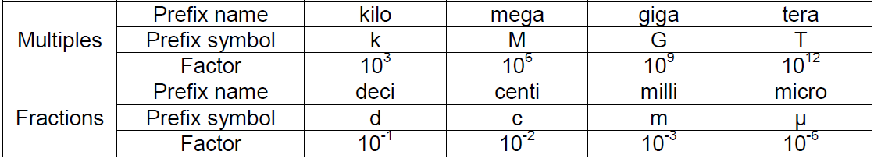

m amsl – metres above mean sea level
YBP – years before present

Thus, kilometre is abbreviated as km and megametre is abbreviated as Mm. The base unit of the dimension mass is already kilogram, or kg, but the ‘kilo’ is removed when smaller (fractions) or larger (multiples) of a dimension is indicated, e.g. microgram or μg.
Non-SI units (e.g. the International System of Quantities (ISQ) such as volume (length³) that are derived from SI units) that are accepted for use within the SI include the tonne (t), litre (l), hectare (ha), minute (min), hour (hr or h), day(d), degree of arc (°), minute of arc (‘), second of arc (“) and decibel (dB). The common prefixes may also be used with some of these units and symbols, e.g. kilolitre (kl) or millilitre (ml).
Note: always add a non-breaking space (ctrl+shift+space) between a number and unit, but not between a number and the % sign e.g.: 54 kg, but 54%.

Conventions relating to numbers in documents
- A non-breaking space (shortcut: <ctrl>+<shift>+<spacebar>) should be used as a thousands-separator, i.e. R10<ctrl>+<shift>+<spacebar>000, and not R10 000 (normal space) or R10,000.
- A decimal point is used, not a decimal comma, i.e. R500.00 and not R500,00.
- In general text, the numbers one to ten are written out, anything larger is indicated in numerals, e.g. 11, 25, 110 etc. The exception is when statistics are provided, then all numbers are numerals, e.g. ‘10%’ or ‘10 per cent’ rather than ‘ten per cent’; or ‘9.4 seconds’ rather than ‘nine point four seconds’.
- Numbers, dates and years are not used to start a sentence, e.g.:
- ‘The year 2001, …’ or ‘In 2001…’ and not ‘2001 was a great year’.
- ‘Wednesday, 8 February 2017 was…’ or ‘On 8 February 2017…’ and not ‘8 February 2017 was…’.
- ‘Two-hundred-and-fifteen species occur in…’ or ‘A total of 215 species occur in…’ and not ‘215 species occur in…’

Fractions: should be inserted as superscript numerator, fraction slash, subscript denominator, e.g. ³⁄₈

Numbering: Bulleted or numbered lists (built-in formatting in MS Word) may be used for lists.

Hidden text and hyperlinks: Remove all hidden text. Check that hyperlinks are functioning and are shown as blue underlined text

Tables:
- Whole table should be left aligned.
- Use basic table style in MS Word. Aside from bold and italic, subscript and superscript, do not apply styles and formatting to the table.
- Table headings: left aligned, bold, same size or one size larger than table text, no full stop.
- Table font: Arial Narrow, 9pt
- Table format: choose a simple style that suits the content and size of table, e.g. one of the following styles (in a colour that fits with the environment colour) :
  - Plain grid
  - Light to medium shading only (too dark and printed versions will obscure the text)

Textboxes: Create a text box using Word’s “insert textbox” tool, as then you can caption it and captions can create a list of boxes. Font should be the same as the text font, but single line spacing.

Headers: use the same header throughout the document: “National Biodiversity Assessment 2018. Technical Report Volume X, xyz environment”

Footnotes and endnotes: Use MS Word’s built-in footnote system. Font: Calibri 9pt. Do not use endnotes.

Literature references: Ensure that all literature references mentioned in the text are included in the list of references and vice versa: authors, dates (marked a, b, c, etc. if relevant). Use the Harvard style of referencing (http://openjournals.net/files/Ref/HARVARD2009%20Reference%20guide.pdf).

Synthesis report will use numbers and a long list of references at the back. Make sure that we have your reference list.

Advice about using a reference manger:
We are using Mendeley for synthesis. Joining the NBA report 2018 group via the Mendeley website (www.mendeley.com):
1. Login to the Mendeley website and select the ‘Search’ tab
2. Select ‘Groups’ and type nba report (this is a faster search than typing the actual title for some reason) and select ‘Search’
3. There should be ±900 groups but if you scroll down the first page or second page (this depends on the number of members in the group) you should see ‘NBA report 2018’ (highlighted in red below).
- it is not the NBA 2018 – Take3 group

4. Select the group and select ‘Join’

Inviting new members to the NBA report 2018 group on Mendeley:
1. Login to the Mendeley website and select the ‘Groups’ tab at the top of the page
2. Select the NBA report 2018
3. Select ‘Invite members’ button (highlighted in red below)
4. Type the email addresses of people which you would like to add as members and then select ‘Invite’

Accessing the NBA report 2018 group on Mendeley Desktop:
You either need to accept an invitation to the NBA report 2018 group or join it by searching for the group on the Mendeley website. Once you are a member you can access the references within the group.
1. Open Mendeley Desktop
2. Select ‘NBA report 2018’ under ‘Groups’ (highlighted in red below)

Citing from the NBA report 2018 group in Word:
1. Select ‘Insert Citation’ from the Mendeley add-on under the References tab in Word
2. Go to the drop-down arrow below the search bar and make sure the ‘NBA report 2018’ is selected as the default will be ‘My Library’
3. From there you can search all references within the NBA report 2018 database

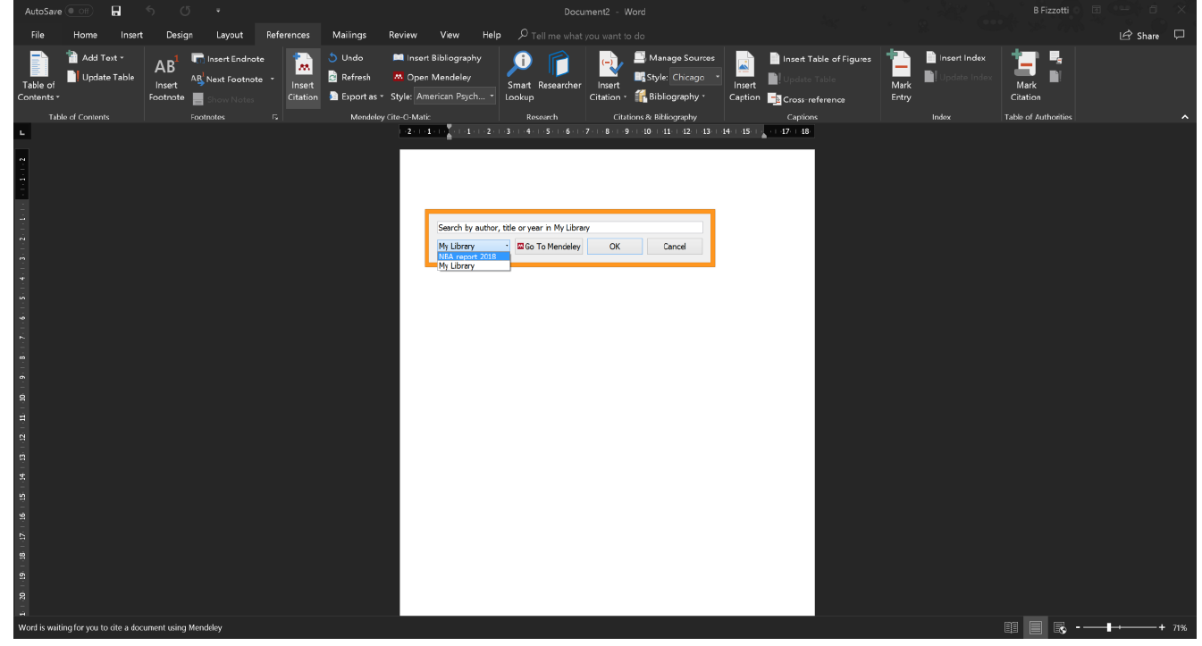

Images / Graphs / Maps
- Images should be high quality, in sharp focus and with clear subject matter. Quality should be no less than 300 dpi for printed materials.
- Drop into the Word document as *.JPG. Image placement should be with clean lines, i.e. square or rectangle shapes, with a white border between photographs.
- Maps of South Africa should be half-A4-sized and centre on the page. We suggest using the template for maps to make them consistent throughout the report.
- Refer to figures in the text as ‘Figure 1’ or ‘Figure 1b’, and not ‘Fig. 1’ or ‘Fig. 1b’. Use “insert cross-reference” tool to help you.
NBA 2018 has standard RGB values for map and graph colours. There are also avl or lyr files (legend files for ArcView and ArcGIS) that go with the shapefiles to give the colours for biomes, vegetation types, etc.

Graphs
All data must be supplied with graphics to allow for recreation of the graph. i.e. supply the excel sheet.

Horizontal graphs are usually used for TS and PL, and should have the darker colours on the left of the graph. This means that the PL graphs are the other way around to NBA 2011 and should look like this:

Maps
- Maps should be projected:
Albers Equal Area with the 25°E central meridian, first parallel at 24°S and second parallel at 33°S. These parallels are often used as negatives to indicate location south of the equator. This can be set in ARCGIS and in QGIS and R.

PROJCS["AEA_RSA_WGS84",GEOGCS["GCS_WGS_1984",DATUM["D_WGS_1984",SPHEROID["WGS_1984",6378137.0,298.257223563]],PRIMEM["Greenwich",0.0],UNIT["Degree",0.0174532925199433]],PROJECTION["Albers"],PARAMETER["False_Easting",0.0],PARAMETER["False_Northing",0.0],PARAMETER["Central_Meridian",25.0],PARAMETER["Standard_Parallel_1",-24.0],PARAMETER["Standard_Parallel_2",-33.0],PARAMETER["Latitude_Of_Origin",0.0],UNIT["Meter",1.0]]
- Most maps will be A5 landscape to fit across a whole portrait page. In some instances the map will be A4 landscape to fit across an A4 page landscape.
- Text should not be smaller than 8 font at A5 (this means if you rescale an A4 map down to A5, the font should be at least 10 font in A4 map). Arial is preferred.
- Maps should have scale bar (basic one with 500km bar) no need for increments at a national scale
- Simple black line border or no border
- Use a simple north arrow as shown or omit
- Save in a .pdf AND .tiff format
- Save at resolution of >300dpi
- The layers used to make a map must always be available to recreate the map if required (map packages in ARCGIS can be useful for this).
- Always provide a suggested caption – since the caption must guide the interpretation
- Colour is allowed
- Note that transparencies make the files large – but we can use them (.png format can’t handle transparencies, hence the preference for .tiff)
- If one makes a multi panel map then only one scale bar and arrow need be used. Panel maps need to have (a), (b) etc in top left of each panel and need to be described in full in the caption
- Provinces or biomes or catchments or other guiding regions can be used depending on the map
- If provinces are used, then use the 2011/2012 boundaries.

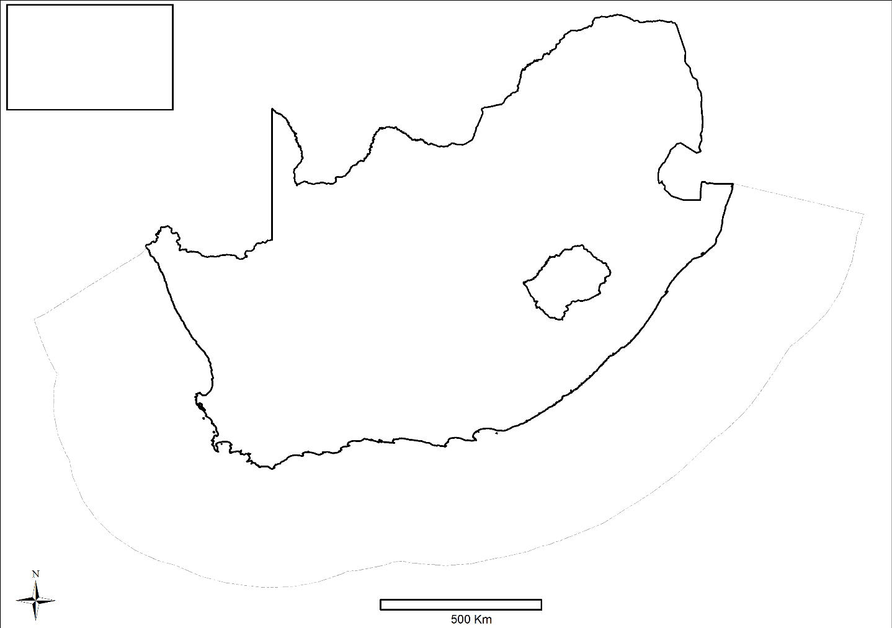
Figure 1. xxx
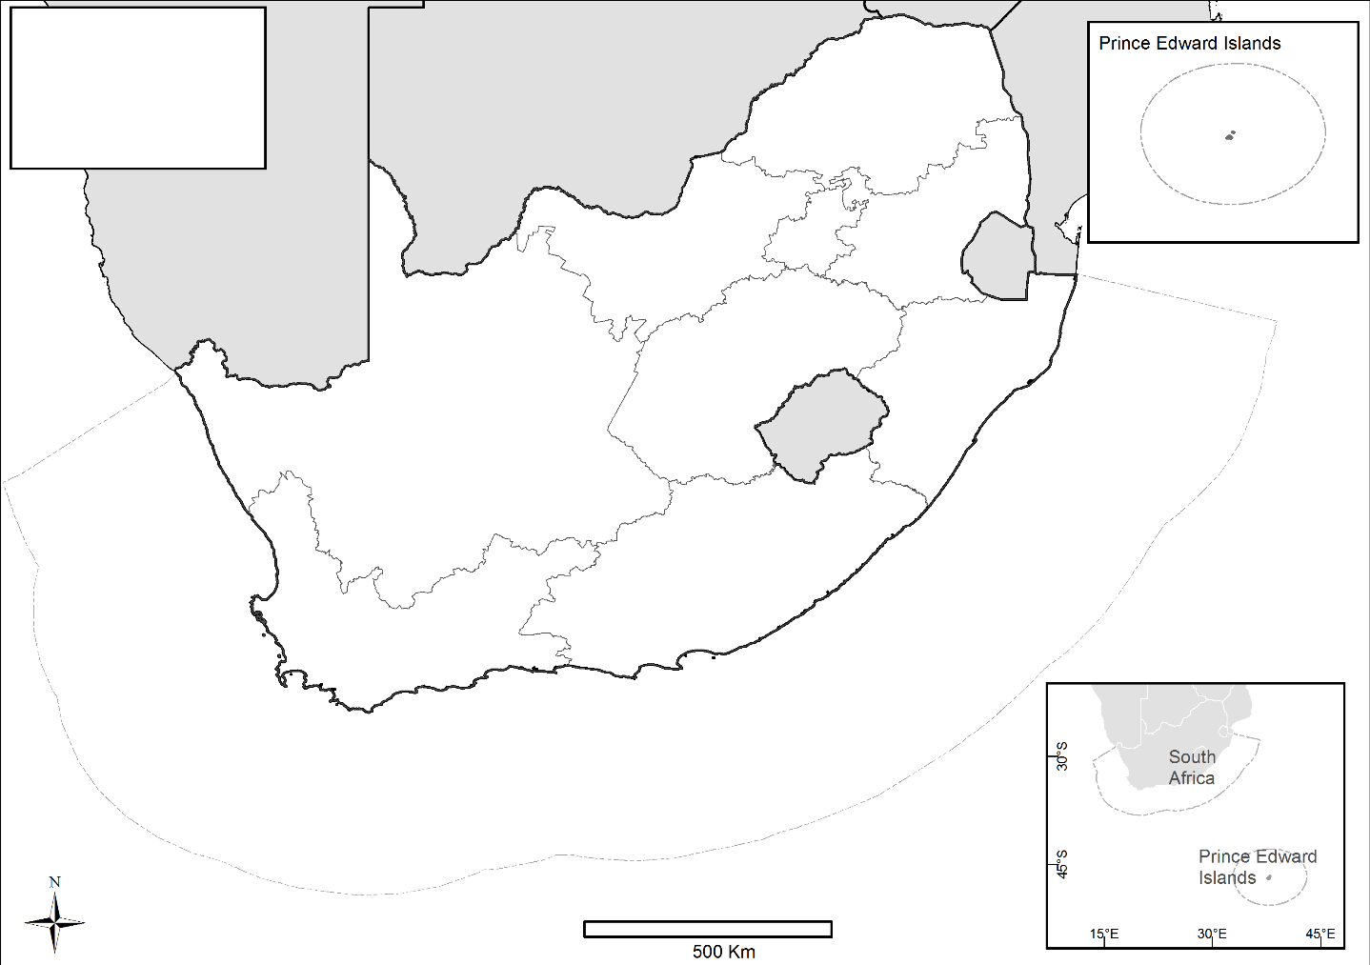

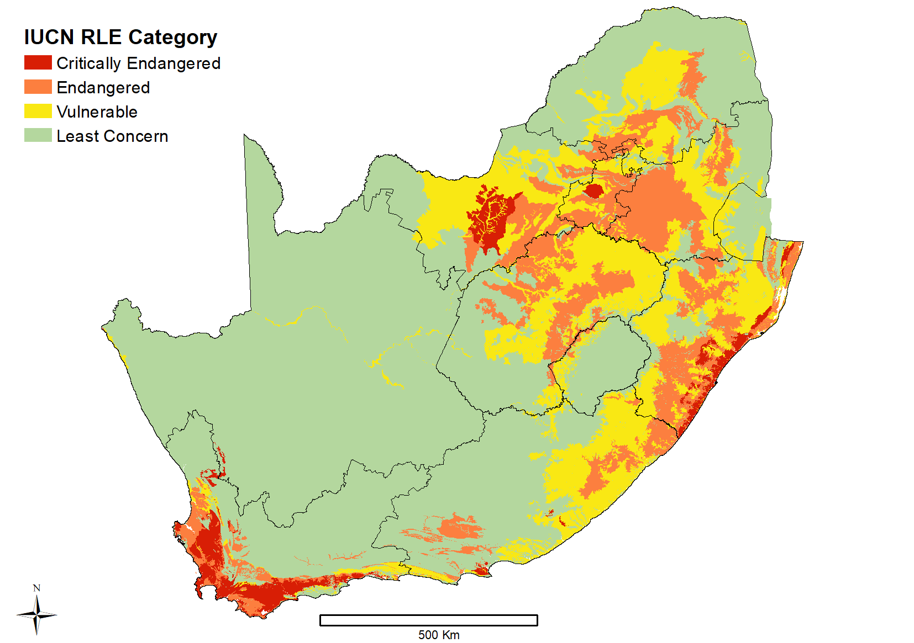
Figure 2. Example MAP, A5 in size, projection set to Alber equal Area (25, -24, -33 wgs84), and scale set to 1: 10 000 000, font must be set to display as min 6-8 font. This is why one uses a A5 size, it matches the destination size well enough to preserve font sizes. I use ariel font for the key.
Captions for figures, graphs, tables, boxes
When creating maps/graphs, the title must not be in the map itself, it should always be created as a caption in WORD afterwards.
- Use the caption style in Word: Calibri, 9pt, blue text. Use the captioning tool so that it automatically updates the List of Figures.
- Placement: centred under a Figure and Graph, above a Table and Box
- Simple captions should follow the following format:
Figure 1. Aloe ferox in habitat at Addo National Park.
- If a longer caption is required, write a short caption that can carry over into the List of Figures and then a longer explanation below in the same kind of font used in the caption (just not styled as a “caption” style).
Figure 1. Aloe ferox detail. A, B, close-up of inflorescence; C, cross-section of leaf; D, in habitat at Addo National Park. Scale bars: A, 5 mm; B (at A), 10 mm; C, 7.5 mm. (The portion after “detail.” should be non-caption style so that only the short version ends up in the list of figures/tables, but try to make it look like part of the caption by using the same font size and colour)

Codes for colours
Codes for colours

Realm colours
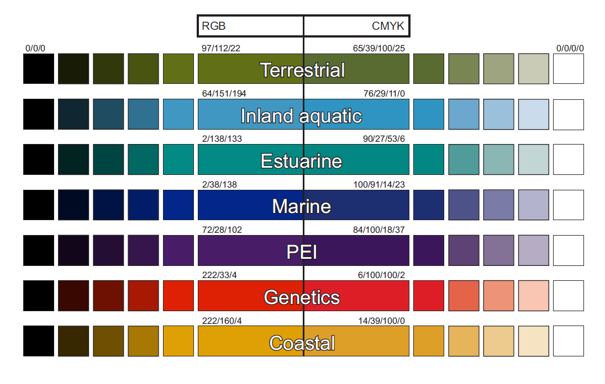

Ecosystem Threat Status (as per IUCN colours with some adjustments)
 |  | R | G | B
 | Critically Endangered | 216 | 30 | 5
 | Endangered | 252 | 127 | 63
 | Vulnerable | 249 | 232 | 20
 | Least Concern | 180 | 215 | 158
 | Ecosystems of special concern
Ecosystem Protection Level
PROTECTION LEVEL |  | R | G | B
Not Protected | Changed from invisible green to grey | 166 | 166 | 166
Poorly Protected | Changed – but more grey (from 216 / 227 / 191) | 213 | 222 | 196
Moderately Protected |  | 132 | 171 | 92
Well Protected |  | 75 | 110 | 0

Pressures
  - Warm brown continuum from Lara for all realms

PRESSURE |  | R | G | B
Low |  | 223 | 220 | 199
Medium |  | 175 | 168 | 117
High |  | 122 | 116 | 70
Very high |  | 88 | 82 | 50

  - Tilla’s colours for species pressures match to terrestrial colours for pressures
PRESSURE |  | R | G | B
No threats |  | 48 | 30 | 6
Pollution |  | 97 | 65 | 56
Transportation & service corridors |  | 99 | 76 | 39
Agriculture |  | 133 | 76 | 13
Geological events |  | 153 | 102 | 0
Biological resource use |  | 180 | 121 | 42
Other threats |  | 231 | 160 | 54
Human intrusions & disturbance |  | 159 | 134 | 9
Climate change & severe weather |  | 178 | 149 | 78
Energy production & mining |  | 122 | 116 | 70
Natural system modifications |  | 88 | 82 | 50
Invasive and other problematic species, genes & diseases |  | 61 | 69 | 64
Residential & commercial development |  | 128 | 128 | 128
Will move similar colours apart on the graphs
Condition
FOR ALL WET REALMS – aquatic, estuarine, marine

New names as per new table in section above |  | R | G | B
Natural / near natural |  | 110 | 159 | 212
Moderately modified |  | 165 | 197 | 199
Heavily / intensively modified |  | 129 | 171 | 167
Permanently / irreversibly modified |  | 136 | 129 | 78

Terrestrial: no need for a colour scheme as only natural and not natural

Responses
Response colours
Response colours | Red | Green | Blue
No response | 91 | 66 | 114
Some kind of response | 100 | 103 | 130
Gazetted/signed off/etc. | 117 | 164 | 179

Rate of loss graph in terrestrial / years to collapse
grey scale

RGB codes for recreating the Biodiversity Priority Areas map:
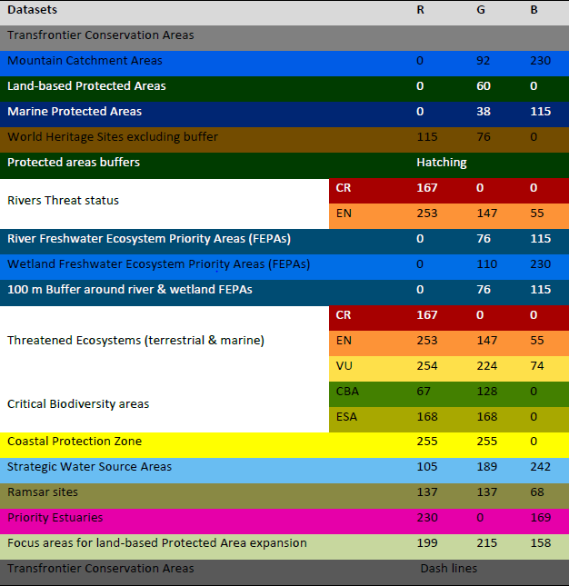

Handling uncertainty
We want a standardised version of how to handle uncertainty and likelihood in the NBA 2018.
More reading on this is available in the following references:
- Ash, et al 2010 Ecosystems and Human Well-being: A Manual for Assessment Practitioners. Island Press. ISBN 978-1-59726-711-3 (Primarily pages 145-147) http://www.ecosystemassessments.net/resources/ecosystems-and-human-well-being-a-manual-for-assessment-practitioners.pdf
- Hawkins et al 2015. Framework and guidelines for implementing the proposed IUCN Environmental Impact Classification for Alien Taxa (EICAT). Diversity and Distributions, (Diversity Distrib.) (2015) 21, 1360–1363 (Primarily pages 26-29)
- IPBES Deliverable 2(a) Guide on production and integration of assessments from and across all scales. Available http://www.ipbes.net/sites/default/files/downloads/IPBES-4-INF-9_EN_0.pdf (primarily Chapter 4)

Why? (Copied directly from various places in Ash et al. (2010))
Assessments should focus not only on what is known with certainty by the scientific community but also on what remains uncertain. The clarity that assessments have given to areas of real scientific uncertainty (such as climate change in the 1990s) has been just as important in guiding policy as the clarity they have provided where there is broad scientific agreement. Moreover, by identifying areas of scientific uncertainty that matter for policy decisions (e.g., the ability to predict thresholds of change in socioecological systems), assessments can also help stimulate more support for scientific research.
Estimates of certainty are derived from the collective judgment of authors, observational evidence, modelling results and/or theory examined for this assessment. The uncertainty language should be used appropriately and consistently in the key findings of each chapter.

How? (Copied directly from various places in Ash et al. (2010))
Incorporate uncertainty terms in the form of footnotes or embedded within the sentence. Footnotes can be easier to use as they allow greater flexibility in writing key findings. Uncertainty can also be presented in graphical form using radar plots or snowflake charts that signify increasing confidence as it increases in size. See Moss & Schneider (2000) for further discussions on graphical approaches to communicating uncertainty.

Advice from the IPBES guideline for assessments:
Confidence terms should always be used in two key parts of an assessment:
- They should be assigned to the key findings in Executive Summaries of the technical chapters in an assessment report.
- Within the Summary for Policymakers.
Author teams will always be required to make qualitative assessments of confidence based on expert estimates of agreement and evidence. Depending on the nature of the evidence supporting the key message or finding, quantitative assessments of confidence may also be possible. Quantitative assessments of confidence are estimates of the likelihood (probability) that a well-defined outcome will occur in the future.
In no case should the terms in Figure 4.1 (qualitative terms) or Figure 4.2 (quantitative terms) be used colloquially or casually to void confusing readers. Only use these terms if you have followed the recommended steps for assessing confidence.
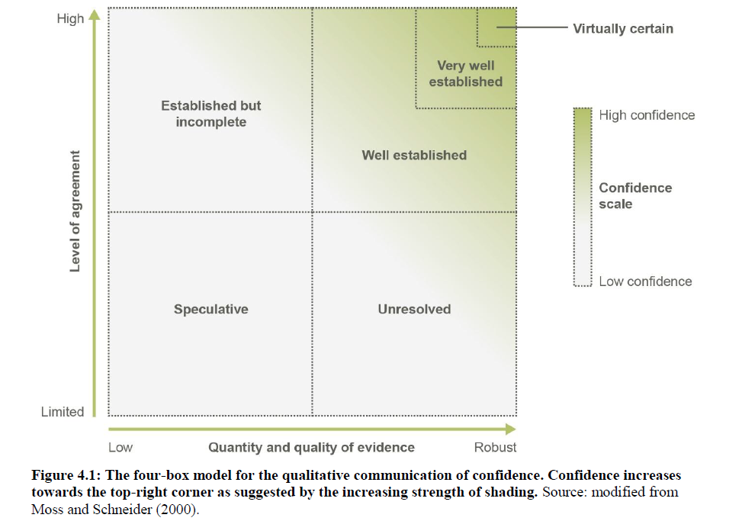

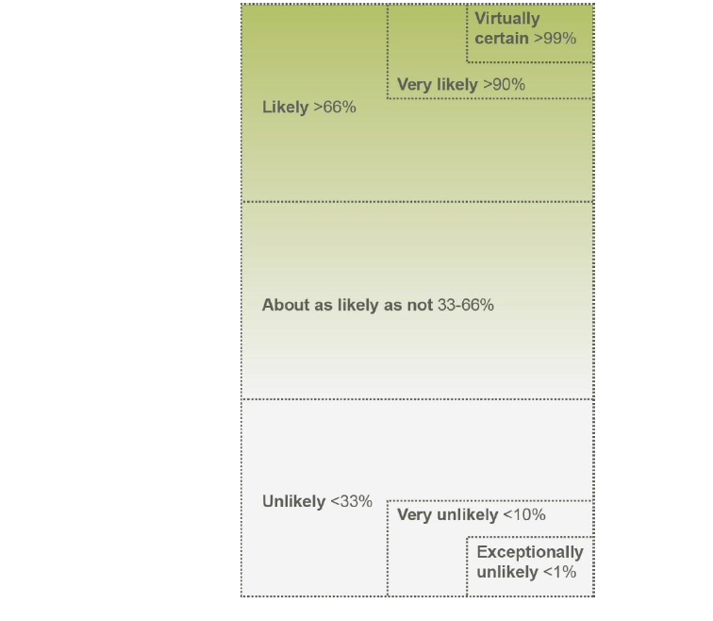
Figure 4.2. Likelihood scale for the quantitative communication of the probability of an outcome occurring. Note that the extreme levels of probability are nested within the broader levels of “likely” and “unlikely”. Source: modified from Mastrandrea et al. 2010.

Advice from the Hawkins et al paper for uncertainty in classifying alien taxa:
A number of factors will affect the confidence in an assessment, including the availability, reliability and type of data used as evidence of impacts; the spatial scale over which data were collected; the ease of interpretation of the available data; and whether or not all available data are in agreement with respect to the magnitude of recorded impacts (although variation in impacts across space and time is to be expected).
Confidence is categorised into three levels; high, medium and low.
- High confidence should be assigned when there is relevant direct observational evidence to support the assessment; the data are reliable and of good quality; impacts are recorded at the typical spatial scale at which original native communities can be characterized; and all evidence points in the same direction.
- Medium confidence should be assigned when there is some direct observational evidence to support the assessment, but some of the data are inferred (e.g. impact estimated from mathematical models); impacts are recorded at a spatial scale which may not be relevant to the scale over which original native communities can be characterized but extrapolation or downscaling of the data to relevant scales is considered reliable, or to embrace little uncertainty; and/or there is some degree of ambiguity in the direction or magnitude of the impact.
- Low confidence is defined as no direct observational evidence to support the assessment, for example only data from other species have been used as supporting evidence; or data are of low quality or strongly ambiguous; or impacts are recorded at a spatial scale which is unlikely to be relevant to the scale at which original native communities can be characterized and extrapolation or downscaling of the data to relevant scales is considered unreliable or to embrace significant uncertainties.
Confidence levels may be translated into arbitrary probabilities that the assigned category is the correct one. High confidence means that the assessor feels they have approximately 90% chance of the given score being correct. Medium confidence is defined as 65-75% chance of the assessor score being correct and Low confidence only 35% chance of being correct. See Table 2 on page 29 of Hawkins et al 2015.

Advice for peer review
Copyright and plagiarism: On submission of the draft technical report to reviewers, the author(s) should vouch that the manuscript is their own work and that all works that were consulted in the preparation of the text are adequately referenced. If the editors/reviewers become aware of any instances of copyright infringement or plagiarism, the manuscript will be returned to the author(s) for correction and/or rewriting.

It is crucial that peer-reviewers are given clear guidance, including:
- a background to the assessment;
- the timeline for peer-review;
- what reviewers are expected to comment on e.g.
- the overall direction and content of the report
- methods and analysis
- overarching conclusions
- whether there is any additional material that should be considered for inclusion;
- how to submit comments (i.e. email, post or online);
- how the reviewer will be acknowledged in the report (if applicable);
- how their comments will be addressed by the respective authors; and
- when outputs are expected to be disseminated.

More advice is found in red text in the NBA 2018 Technical Report Template document. Formatting is correct in the template so that authors can merely start typing in the template.

Any comments / corrections / suggestions to:
Carol Poole; 021 799 8695; c.poole@sanbi.org.za

